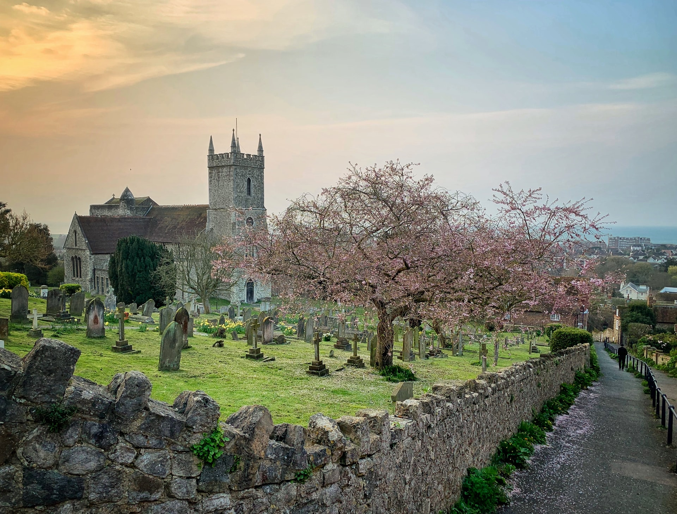

Image: Martin Drew on Unsplash

Church name
location

This section of the case statement offers reflection on maintenance, mission and ministry in our church and identifies some key areas for development.
The 3 main strengths  in our church | [fill in details]
 | [fill in details]
 | [fill in details]
The 3 main weaknesses  in our church | [fill in details]
 | [fill in details]
 | [fill in details]
Our agreed  or provisional plans  for ministry  and mission over the next  1-2 years | [fill in details]
 | [fill in details]
 | [fill in details]
 | [fill in details]

This second section invites reflections on our stewardship practice and culture to inform our thinking and the shape of our Giving in Grace programme.
Parish Giving Scheme  We work hard at growing planned giving, primarily through the Parish Giving Scheme. Good literature, clear website & social media encouragement. (More) | [insert brief commentary]
Good stewardship practice  We have a clear stewardship plan: preaching generous discipleship; celebrating Generosity Week; an annual giving ‘ask’; Gift Days as appropriate; regular thanks for giving; Maximise Gift Aid; small group learning; signpost pastoral support for debt, money concerns. | [insert brief commentary]
Digital Giving  We have contactless giving in church, an online giving platform; accessible, clear giving web page; effective social media. | [insert brief commentary]
Legacy giving  We have a clear plan to encourage legacy gifts: a legacy policy, online and hard copy literature; a legacy officer, good story telling of the difference legacies make. | [insert brief commentary]
Budgeting and planning  We prepare an annual budget & we communicate it and our ongoing finances creatively. We use reserves well with a reserves policy; we connect giving and the mission it makes possible. We gift a % of our annual income. | [insert brief commentary]
Other income streams  For example: a sustainable fundraising plan; maximise trading income (e.g hall rentals); grant funding; Friends groups etc. | [insert brief commentary]

Section three of this case statement captures the financial analysis, often done by the treasurer on behalf of the planning group.

This income and expenditure page of the case statement is created in an Excel spreadsheet. A graphic illustrating how the final page will look is found below.

Guidance on completing this page is at: www.givingingrace.org/Income-and-Expenditure

The finished spreadsheet sits at this point in the document. In Excel hide the gridlines on the View menu and then options include:

- Highlight and copy the spreadsheet data. Delete the body text and illustrative graphic on this page. Paste the spreadsheet data onto this page. Use the MS Word Table Tools design and layout menus to adjust the data on the page.
- Highlight and copy the spreadsheet data. Delete the text and graphic on this page. Paste the spreadsheet data as an image onto this page. Use the MS Word Picture Tools Format menu to adjust the image on the page. Alternatively take a screen grab of the Excel data (Windows+Shift+S) and paste as a graphic on this page.
- Print a hard copy document from Excel, pre-paginated to page 4 & replacing this page.

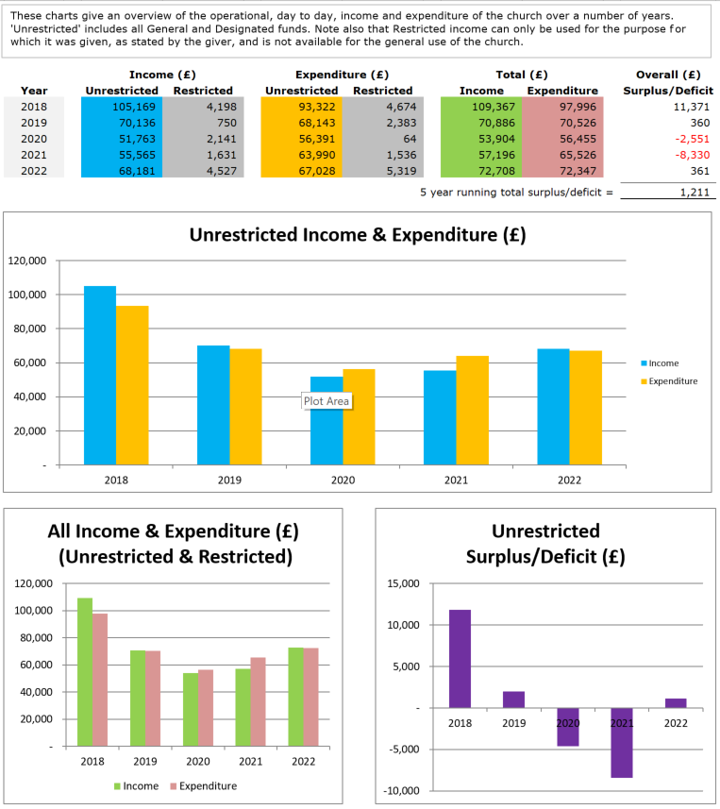

These charts which will be shown on this page give an overview of what is available to the church by way of reserves which can be used for day to day expenditure on maintenance and the mission of the church. They also show restricted funds which can only be used for the purpose for which they were given and, finally, total church funds minus what we owe to others.
This reserves page is created in an Excel spreadsheet. A graphic illustrating how the final page might look is found below.

Guidance on completing this page is at: www.givingingrace.org/Reserves

The finished spreadsheet sits at this point in the document.

Options for inclusion of the page in this Case Statement document are as listed on page 4.
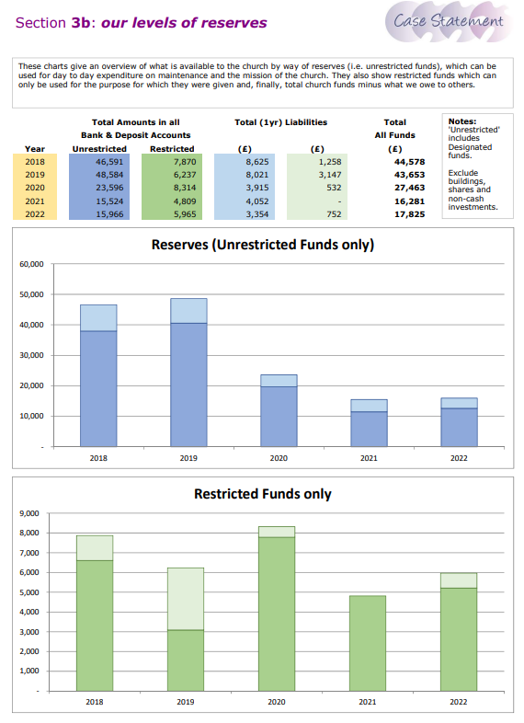

This planned giving profile offers an insight into the pattern of giving in our church. TEPG refers Tax Efficient Planned Givers, those who are able to Gift Aid their giving. OPG refers to Other Planned Givers, those who cannot or do not Gift Aid their gifts.
This planned giving profile page is created in an Excel spreadsheet. A graphic illustrating how the final page might look is found below, left.

Guidance on completing this page is at: www.givingingrace.org/Giving-Profile

For a church with very small planned giving numbers it is likely inappropriate to separate out TEPG and OPG givers. In such cases within the Planned Giving Profile spreadsheet use the Total Planned Giving worksheet for a giving profile for all planned givers, illustrated below, right.

The finished spreadsheet sits at this point in the document: Options for inclusion of the page in this document are the options listed above, on page 4.
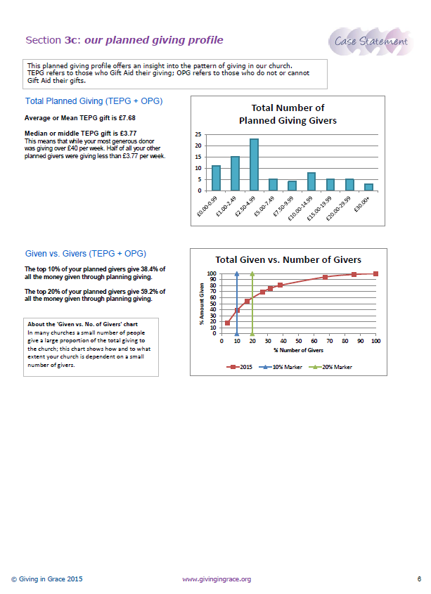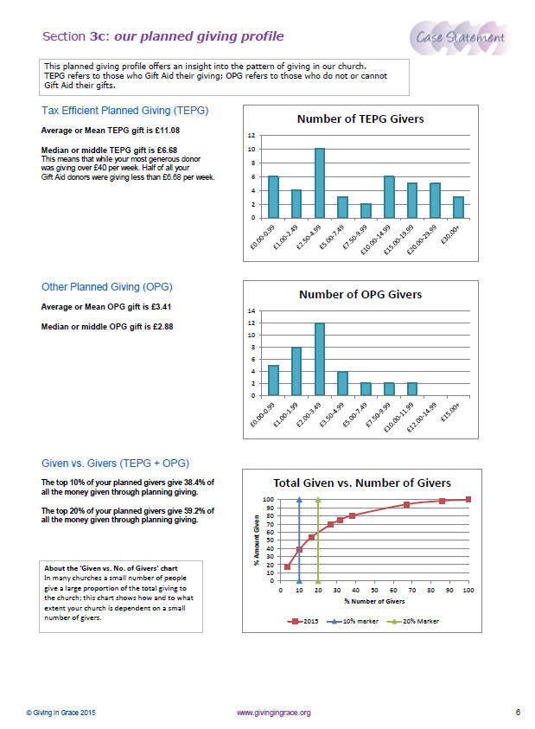

1. The situation we currently face
Briefly summarise here the key financial pressures, issues and opportunities facing the church: e.g. persistent operating deficit; inadequate or over-large reserves; ministry opportunities that could be resourced; the challenge of building repairs, development opportunities within the local community etc

2. From our financial analysis
Brief summary | A short summary of the main issues in the financial analysis and asking the ‘so what’ question.
Our pattern of income and expenditure shows  (section 3a) | Summary:
 | Action we need to take:
Our levels and use of reserves shows  (section 3b) | Summary:
 | Action we need to take:
Our planned giving profile analysis shows  (section 3c) | Average TEPG giving p/w £ [xx]  [replace with total planned giving if appropriate]
 | Median TEPG giving p/w: [xx]
 | Average OPG giving p/w: [xx]
 | Median OPG giving p/w: [xx]
 | Summary:
 | Action we need to take:
Are most of our congregation giving regularly via the Parish Giving Scheme? | What % of all planned givers are using the Parish Giving Scheme (or standing orders)? Can we encourage greater take up? Do we have helpful literature, good stories? Do we model the PGS as leaders, encourage commitment in nurture and confirmation groups?
Digital giving, website and social media | Do we offer contactless and online giving options?  Does our website have an accessible, informative, simple giving page?  Do we tell stories of generosity, speak of giving with passion, discipleship?  Do we make the most of our social media, A Church Near You?
Open plate and envelope giving  (data taken from the budget) | Are we over-reliant on our open plate offertory?  Is our planned giving over-weighted to more vulnerable envelope giving?
Are we making the most of Gift Aid and GASDS? | Are we actively encouraging and promoting Gift Aid across all planned giving? Are we set up to make the most of the Gift Aid Small Donations Scheme? Are we aware, and making people aware, of the administrative ease and time saving and the cash flow benefits of the Parish Giving Scheme?
Our accounts show our mission giving (grants) as | [xx]% of our direct giving income.  [Insert brief comment or aspiration here]
What other income streams can we work to develop in the future? | Is there a future conversation to be had around increasing, for example: our trading income (e.g. more or better hall rentals), sustainable fundraising, Trust funding or exploring a Friends group?  These are all legitimate questions but for future exploration. They should not draw energy from the Giving in Grace focus on regular, committed giving from generous disciples.

3. Our financial challenge
For the coming year the cost to fund the ministry of this church, including our planned developments is: | £[xxx] each week  (Data from the budget in section 5)
We estimate our total income - without any increase in giving - to be: | £[xxx] each week  (Data from the budget in section 5)
An increase in giving is a key element of sustaining and developing our ministry. We believe that we need to increase our giving by: | £[xxx] each week  (Data from the Gift Array, section 6)
We anticipate any increase in income from other income streams to total: | £[xxx] each week  (Data from budget section 5: additional income total divided by 52)

The budget on this page is very simple. It anticipates expenditure and income for the coming year (the plan) and sets a financial target expressed in a weekly amount needed to resource our ministry and mission.

This planned giving profile page is again created in an Excel spreadsheet. A graphic illustrating how the final page might look is found below.

Guidance on completing this page is at: www.givingingrace.org/The-Budget

The finished spreadsheet sits at this point in the document. Options for inclusion of the page in this document are the options listed above, on page 4.
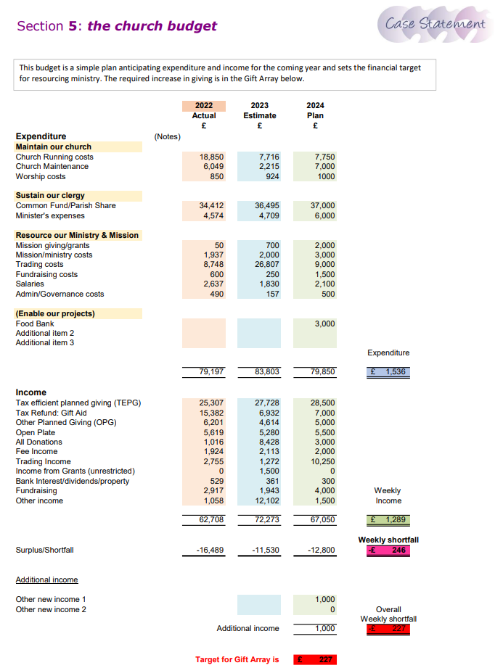

The Gift Array on this page offers a range of possible financial responses. People can choose an appropriate amount and so we respect the diversity in the personal circumstances and faith journey of those we are inviting to meet our stewardship challenge.

This Gift Array page is created in an Excel spreadsheet. A graphic illustrating how the final page might look is found below.

Guidance on completing this page is at: www.givingingrace.org/Gift-Array

The finished spreadsheet sits at this point in the document. The worksheets are protected because of the formulae and there are two options to choose from, as indicated below. Therefore, for simplicity enlarge the gift array worksheet and use the snipping tool (Windows+Shift+S) to select the chosen gift array (automatic or manual).
Next delete all the text on this page except the boxed text at the top and delete also the graphic below. Then paste the image of your chosen gift array onto this page.

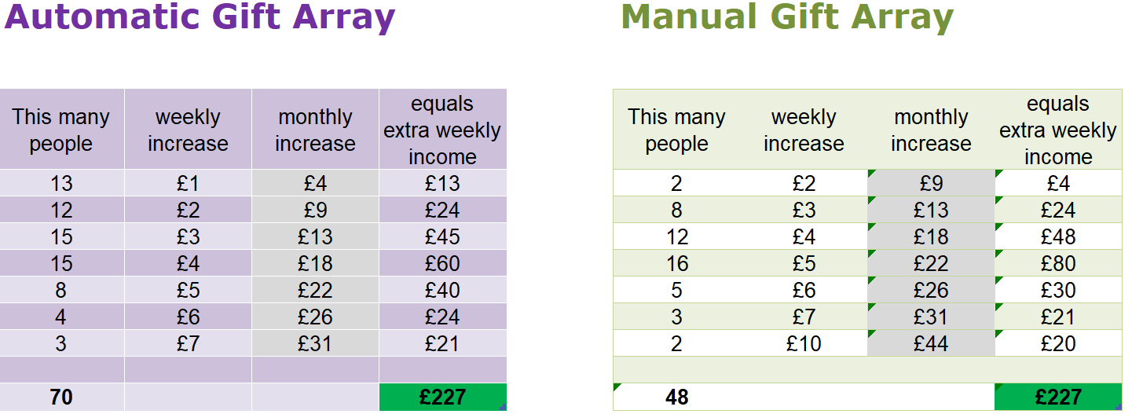

This final section of the case statement invites our church leadership to prayerfully consider and comment on the content of the case and to affirm advocacy and personal support for the Giving in Grace programme.
Do you feel that the strengths and weaknesses and opportunities in section one reflect where the church is now and could be in the future?
Do you have any thoughts on the stewardship reflections in Section 2 of the case statement?
Do you have any particular comments on the data presented in the financial analysis section of the case statement and the conclusions drawn?
Is the budget plan realistic and robust?
Is the financial target in the Gift Array realistic and achievable?
As a church leader do you feel you can commit to our Giving in Grace programme and make a personal giving response, modelling a generosity we pray for from our congregation(s) | NB: Please do not include here any details of your own prayerful and considered response to Giving in Grace. The request here is to indicate your personal support and advocacy for this case statement as the basis of our Giving in Grace programme.

